UPC – HOFFMANN-LA ROCHE V A.MENARINI – ORDER RE PROVISIONAL MEASURES
F. Hoffmann-La Roche AG et al v A.Menarini Diagnostics S.r.l. et al (UPC, Court of First Instance, Local Division Düsseldorf, UPC_CFI_712/2025) – preliminary injunction re. implantable diabetes sensor, claim construction, inventive step, necessity, injunction re. making of infringing product
Dr. Michael Kobler, Bardehle Pagenberg, Munich
By order of 5 December 2025, the Local Division Düsseldorf granted an application for provisional measures filed by Applicants HOFFMANN-LA ROCHE and ROCHE DIABETES CARE based on infringement of the European patent EP 1 962 668 (“EP ‘668”) against three companies of the MENARINI group, the largest Italian pharmaceutics company, by means of their CGM (Continuous Glucose Monitoring) system for patients with diabetes. The Court gave some guidelines on claim construction and legal consequences and applied the standard regarding inventive step which was recently introduced by the Court of Appeal in Amgen v Sanofi. Incidentally, the Court found that the Respondents’ establishment on the relevant market could make provisional measures necessary even if the Applicants had not entered this market yet with their own products.
Headnotes
- An independent process claim and the corresponding description can only be relevant when determining the scope of protection of an independent product claim if the patent specification indicates that it also describes characteristics of the claimed product.
- An injunction covering the making of a product may also be issued if the infringing product has so far been manufactured by a third party outside the contracting member states.
Facts of the case and subject matter of the invention
The attacked product is manufactured by a Chinese company (Changsha Sinocare Inc.) and has been exclusively distributed by the Respondents in Italy and advertised in Germany and France. The Applicants’ own competing product is already available in Germany and is said to be launched in Italy and France in 2026.
Before manufacturing the attacked product for the Respondents (which was distributed in the Respondents’ packaging), Sinocare had distributed their own product in Europe since October 2023. The cooperation between the Respondents and Sinocare was announced in December 2024, and the attacked product was shown at trade fairs and conferences between December 2024 and March 2025. However, the Applicants only realized in July 2025 that the attacked product was marketed in Italy by the Respondents. After having received the results of the technical analysis of the product on 12 July 2025, they filed an application for provisional measures on 7 August 2025.
EP ‘668 is directed at an implantable sensor for determining the concentration of an analyte in a medium, particularly a bodily tissue or a bodily fluid, a device comprising such sensor and a method for producing such sensor. According to EP ‘668, these sensors are used in medical technology to electrochemically determine a concentration of blood sugar, triglycerides, lactate or other analytes. According to the characterizing part of claim 1 (feature 1.4), the insulating carrier substrate between the electrodes “comprises a width such that the at least two electrodes and/or the at least two electrode contact layers extend over the entire width” of this carrier substrate.
Decision by the Local Division
The Local Division granted the application for provisional measures in large parts and only partially dismissed the Applicants’ requests for information and rendering of accounts.
Claim construction and infringement
With regard to the interpretation of feature 1.4 (cf. above), the Court had to decide whether the requirement that the electrodes and the electrode contact layers “extend over the entire width” of the carrier substrate meant that (a) the carrier substrate must be covered to its maximum extension, partially bending down if necessary, or that (b) only the flat portion of the substrate contacting the electrodes must be covered. This plays a role if the cross-section of the substrate is not strictly rectangular and the substrates, thus, has more than one width, as can be seen in the following illustration (mn. 137 of the decision):
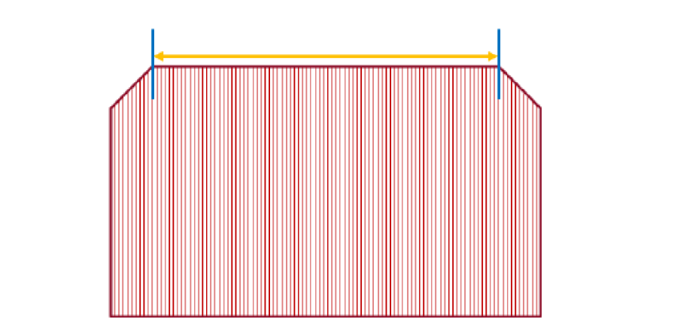
The Court applied the broader claim construction (b), because feature 1.4 refers to electrodes and electrode contact layers, which – according to the skilled person’s understanding – generally extend in two dimensions (layer planes) and do not bend. Furthermore, the electrodes and electrode contact layers fulfill their technical function in the area perpendicularly facing the medium and the object of feature 1.4 is to make this specific area as large as possible. Interestingly, the exemplary embodiments in the patent-in-suit only had carrier substrates with a rectangular cross-section, so the Court could not find an answer to their claim construction question there. Finally, the described understanding was also in accordance with the technical goal of the invention of a simpler manufacturing of the claimed sensors allowing for a wide application of the electrodes and electrode contact layers to the carrier substrate.
In this course, the Court also noted that the specific manufacturing method of claim 18 of the patent-in-suit did not have to be fulfilled, because an independent process claim and the corresponding parts of the description can be relevant when determining the scope of protection of an independent product claim only if, or to the extent, that there are indications in the patent specification that these also describe characteristics of the claimed product (cf. headnote 1.).
As a consequence, the Court found that the attacked product, which comprises a substrate with a non-rectangular cross-section with the electrodes “only” extending over the top, flat areas, realized feature 1.4 (similar to the image shown above).
Validity of the patent-in-suit
Applying the standard set by the Court of Appeal in 10x Genomics v Nanostring, the Court did not find it more likely (than not) that the patent-in-suit was invalid. Incidentally, the Local Division first pointed out that the patent-in-suit had already been granted in 2009 and had not been attacked in opposition proceedings or by a national revocation action.
The Court found that the patent-in-suit validly claimed its priority and that it was novel over the prior art presented by the Respondents. It also applied the recent case law by the Court of Appeal in Amgen v Sanofi and Meril v Edwards regarding inventiveness; in particular, the Court clearly defined the technical problems solved by the invention of the patent-in-suit and found that the person skilled in the art would not have combined the documents submitted by Respondents expecting to find a solution of these technical problems.
Urgency and necessity of provisional measures and weighing of interests
With regard to urgency, the Respondents had argued inter alia that the Applicants must have had knowledge about the technically comparable predecessor product by Sinocare and the cooperation of Sinocare and the Respondents, due to their extensive marketing efforts and the attacked product being launched at various trade fairs and conferences. However, the Court did not follow these arguments, stating that the Applicants did not have an obligation to monitor the market and that the Applicants’ behavior, particularly after finding out that the attacked product was marketed by the Respondents and after they had received the results of the technical analysis, did not constitute an unreasonable delay in asserting their rights.
With regard to necessity, as mentioned above, the Court found that the Respondents’ establishment on the market with the attacked product could make provisional measures necessary although the Applicants had not yet entered the market with their own products in France and Italy, particularly due to the Respondents’ established sales structure.
Finally, the Court weighed the fact that the patent-in-suit will lapse shortly, namely in December 2026, in favor of the Applicants, finding that a large part of the remaining lifetime would be consumed if the Applicants had to wait for a decision in main proceedings. Here, the Respondents had argued that a short-lived injunction would disproportionately disrupt their business.
Take aways:
This decision shows again why the UPC is a good venue also for preliminary injunctions. The reasoning of the decision is detailed and technically convincing and the decision clearly follows the established case law while, at the same time, applying the newest standard set by the Court of Appeal for assessing inventiveness. Regarding necessity, this case is helpful for cases where it is not possible to argue price erosion because the Patentee’s own competing product has not yet entered the market.

